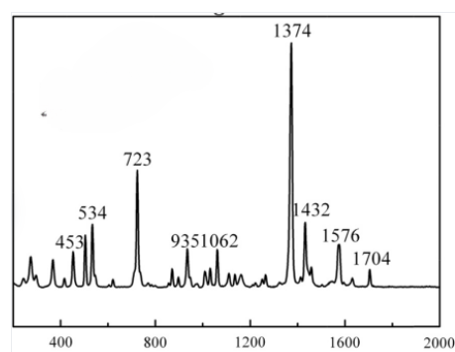

**Figure 1: https://doi.org/10.1016/j.lwt.2014.08.011**

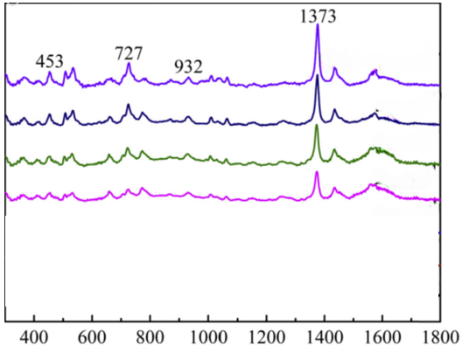

**Figure 2: https://doi.org/10.1016/j.lwt.2014.08.011**

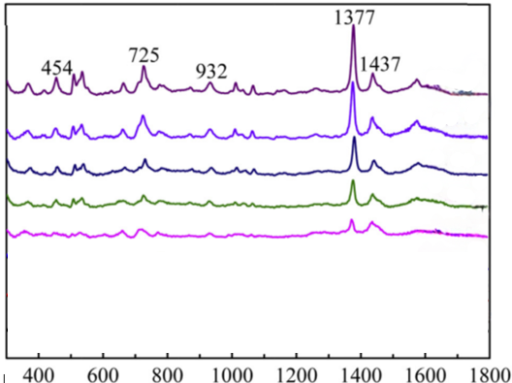



**Figure 3: https://doi.org/10.1016/j.lwt.2014.08.011**

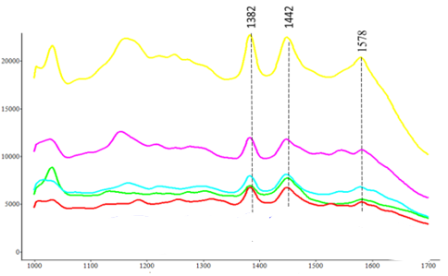

**Figure 4: https://doi.org/10.1021/acs.jafc.6b04774**

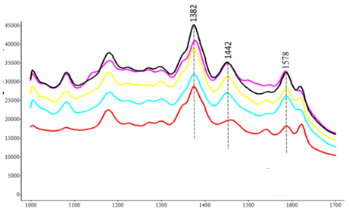

**Figure 5: https://doi.org/10.1021/acs.jafc.6b04774**

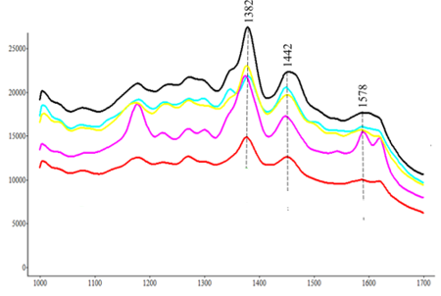

**Figure 6: https://doi.org/10.1021/acs.jafc.6b04774**

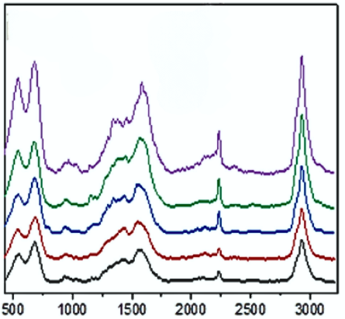

**Figure 7: https://doi.org/10.1080/03601234.2020.1869476**

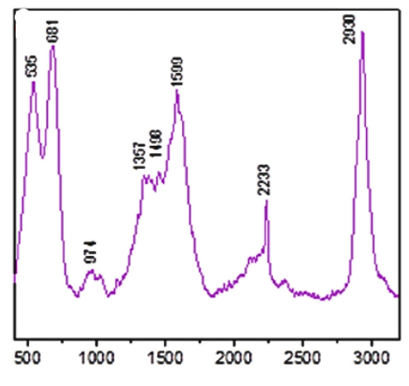

**Figure 8: https://doi.org/10.1080/03601234.2020.1869476**

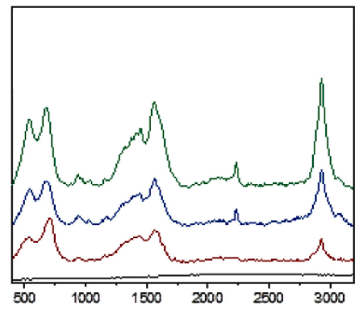

**Figure 9: https://doi.org/10.1080/03601234.2020.1869476**

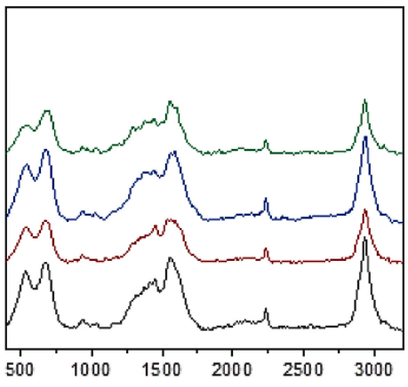

**Figure 10: https://doi.org/10.1080/03601234.2020.1869476**

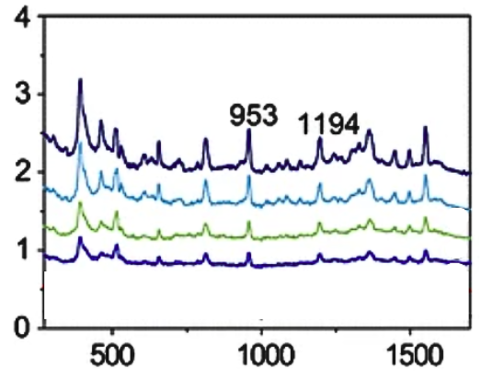

**Figure 11: https://doi.org/10.1007/s00604-016-1760-4**

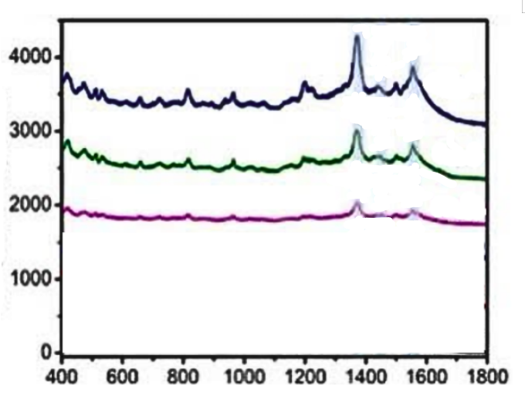

**Figure 12: https://doi.org/10.1016/j.foodchem.2024.140486**

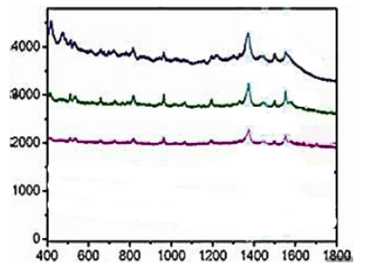

**Figure 13: https://doi.org/10.1016/j.foodchem.2024.140486**

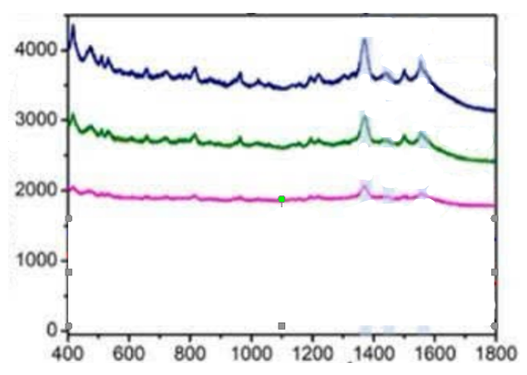

**Figure 14: https://doi.org/10.1016/j.foodchem.2024.140486**

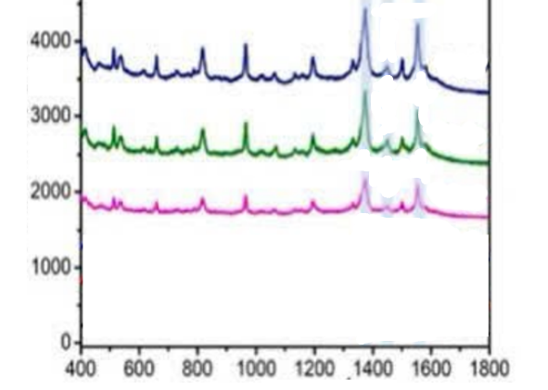

**Figure 15: https://doi.org/10.1016/j.foodchem.2024.140486**

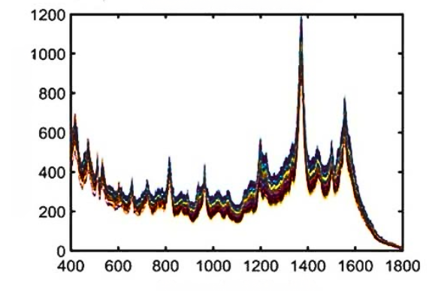

**Figure 16: https://doi.org/10.1016/j.foodchem.2024.140486**

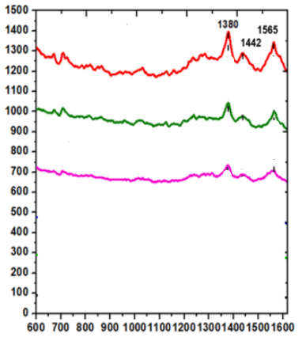

**Figure 17: https://doi.org/10.1016/j.saa.2023.122734**

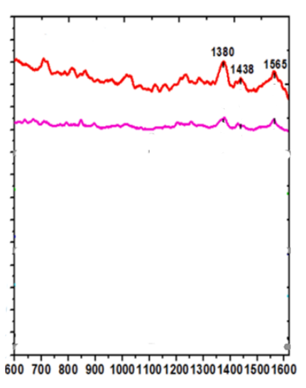

**Figure 18: https://doi.org/10.1016/j.saa.2023.122734**

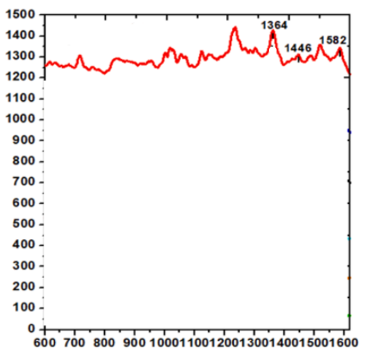

**Figure 19: https://doi.org/10.1016/j.saa.2023.122734**

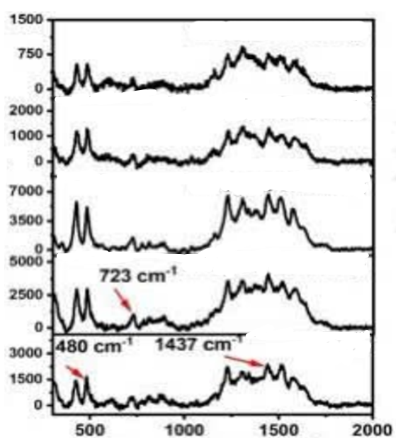

**Figure 20: https://doi.org/10.1039/D3RA05381D**

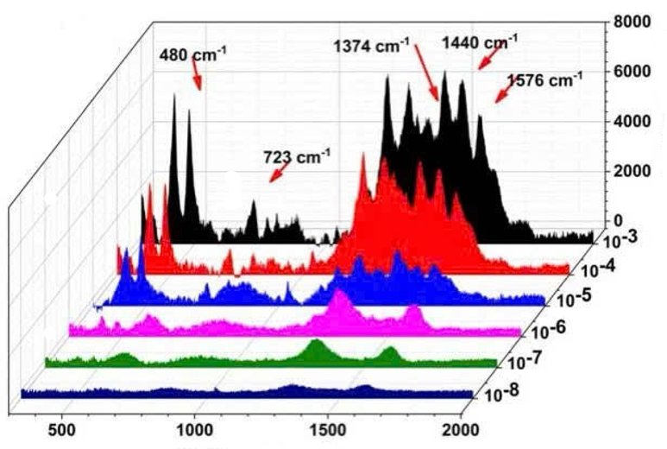

**Figure 21: https://doi.org/10.1039/D3RA05381D**

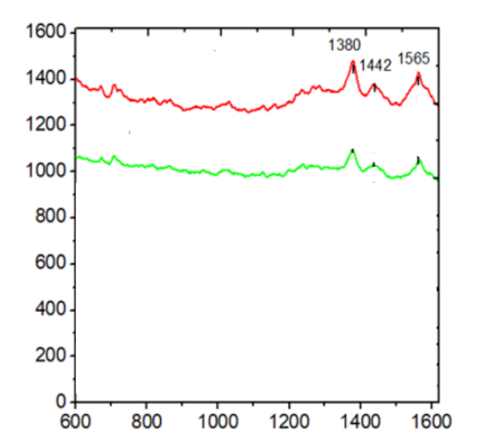

**Figure 22: https://dx.doi.org/10.2139/ssrn.4270353**

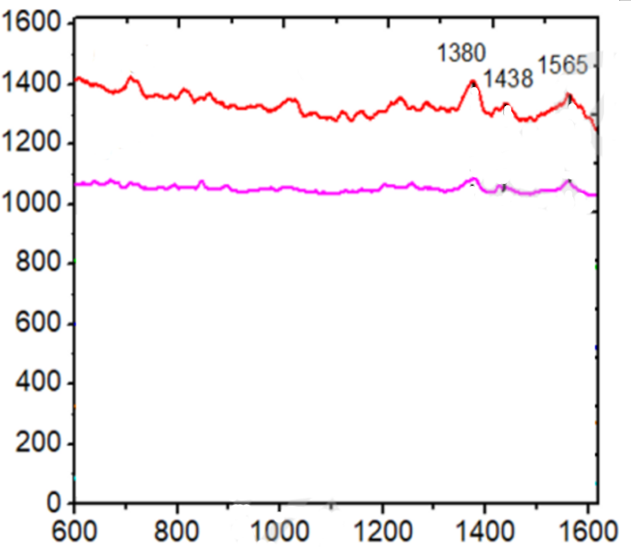

**Figure 23: https://dx.doi.org/10.2139/ssrn.4270353**

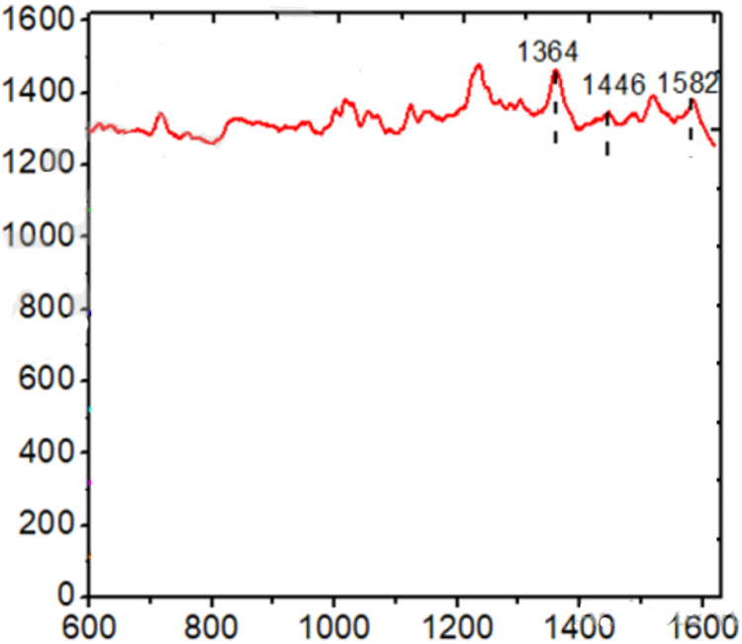

**Figure 24: https://dx.doi.org/10.2139/ssrn.4270353**

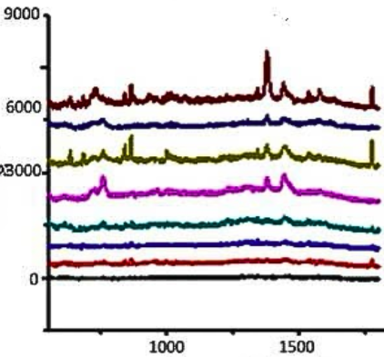

**Figure 25: https://doi.org/10.1021/jf5036417**

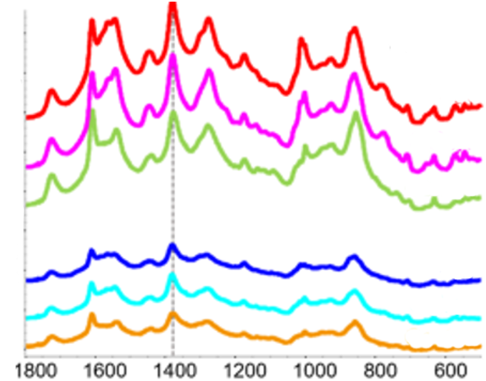

**Figure 26: https://doi.org/10.1021/acsagscitech.4c00587**

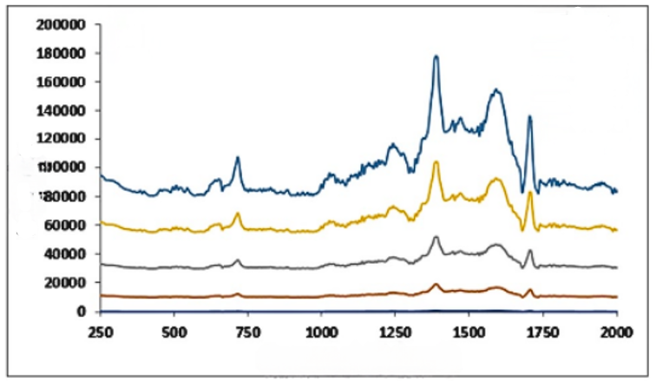

**Figure 27: https://doi.org/10.1007/s11468-024-02671-0**

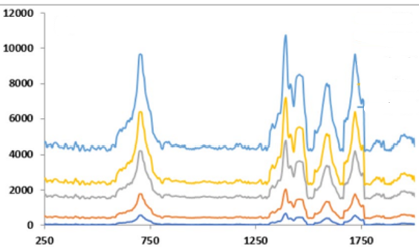

**Figure 28: https://doi.org/10.1007/s11468-024-02671-0**

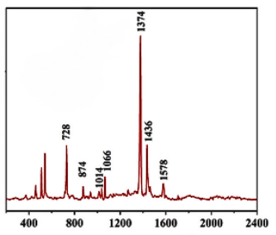

**Figure 29: https://doi.org/10.1016/j.foodchem.2025.142885**

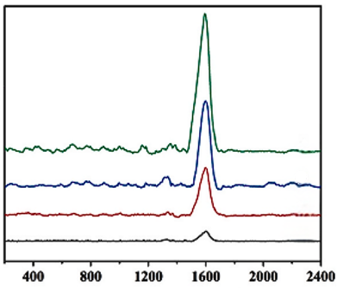

**Figure 30: https://doi.org/10.1016/j.foodchem.2025.142885**

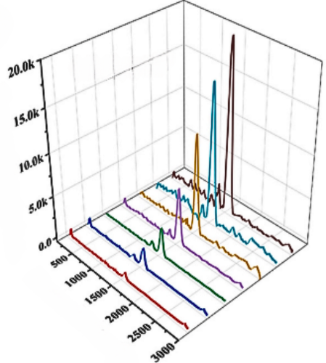

**Figure 31: https://doi.org/10.1016/j.foodchem.2025.142885**

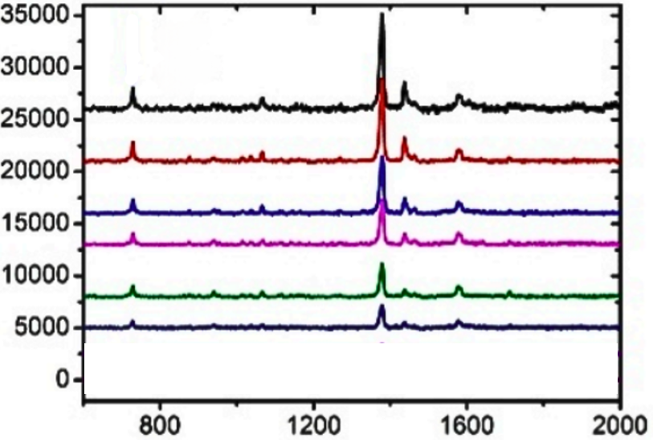

**Figure 32: https://doi.org/10.3390/nano9030384**

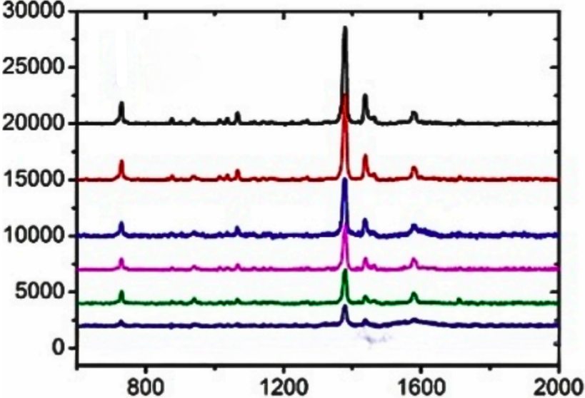

**Figure 33: https://doi.org/10.3390/nano9030384**



**Figure 34: https://doi.org/10.3390/nano9030384**

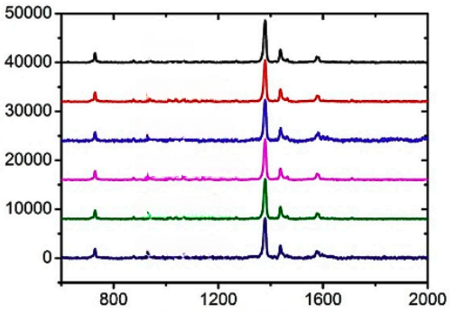

**Figure 35: https://doi.org/10.3390/nano9030384**

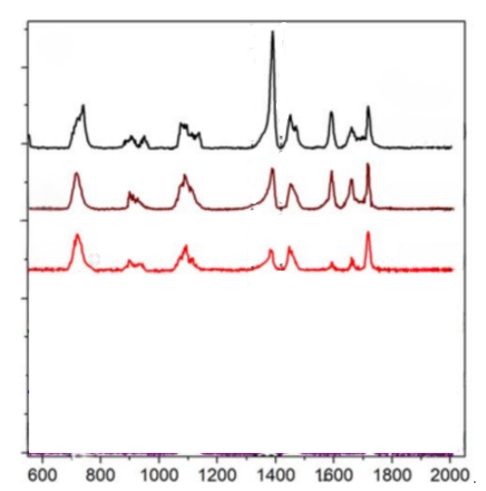

**Figure 36: DOI 10.1088/2043-6254/ab6c5f**

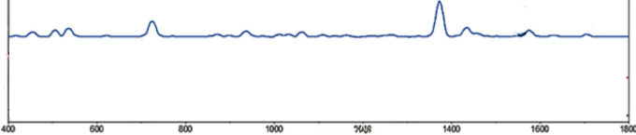

**Figure 37: https://doi.org/10.3390/pr10030442**

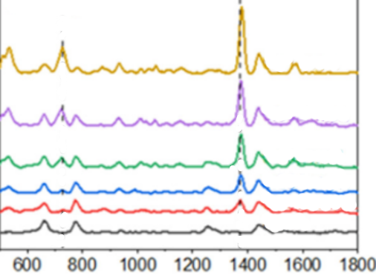

**Figure 38: https://doi.org/10.3390/pr10030442**

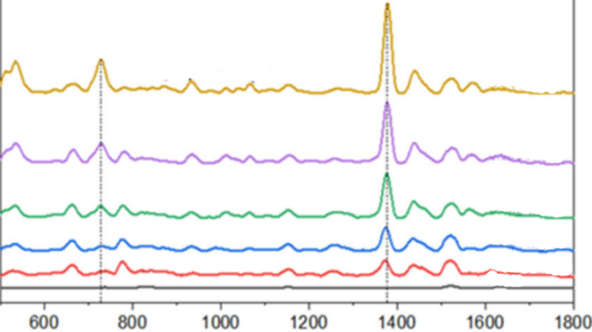

**Figure 39: https://doi.org/10.3390/pr10030442**

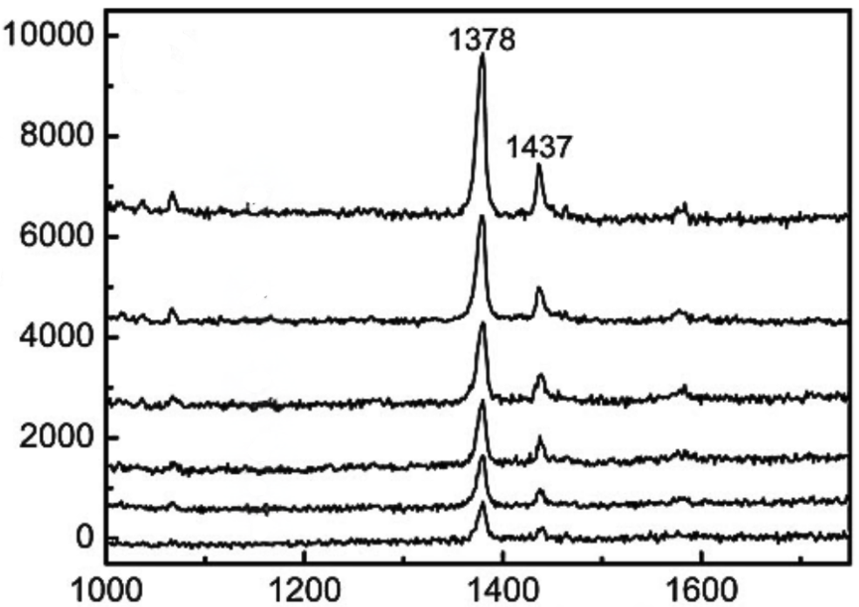

**Figure 40: https://doi.org/10.1063/1.3300837**

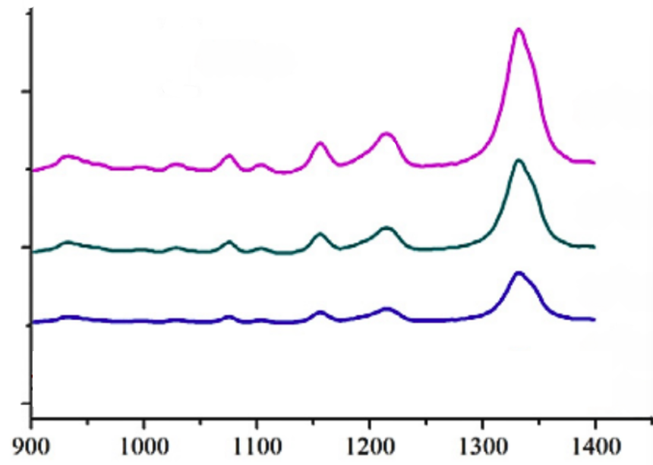

**Figure 41: https://doi.org/10.1016/j.ijleo.2016.08.118**

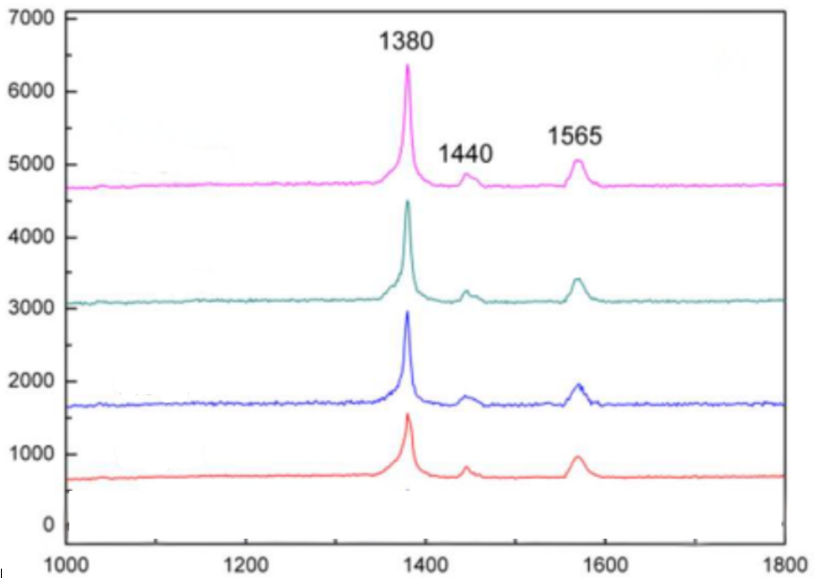

**Figure 42: https://doi.org/10.1039/C3NR00571B**

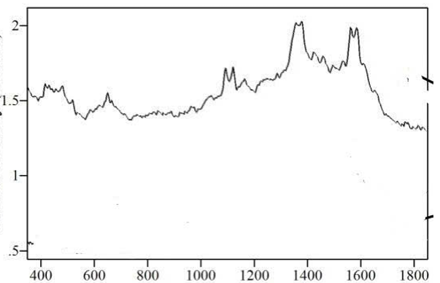

**Figure 43: https://doi.org/10.1117/12.569595**

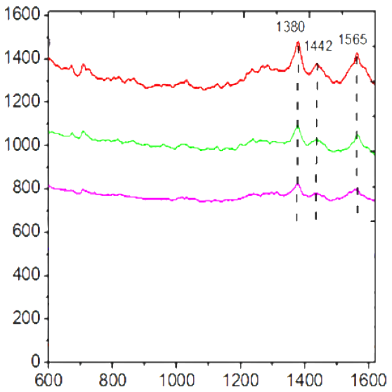

**Figure 44: https://dx.doi.org/10.2139/ssrn.4347307**

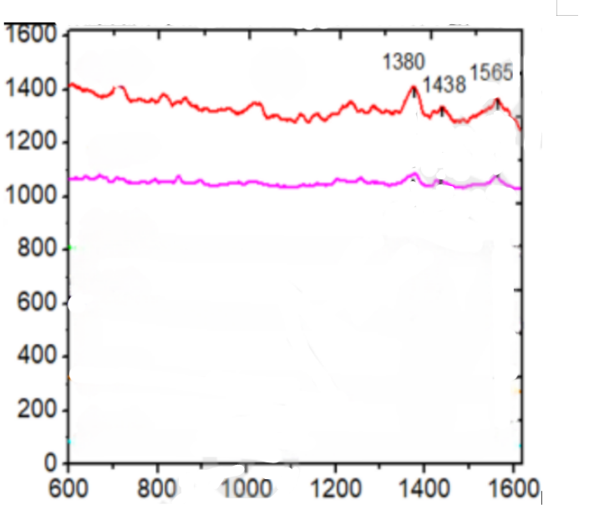

**Figure 45 :https://dx.doi.org/10.2139/ssrn.4347307**

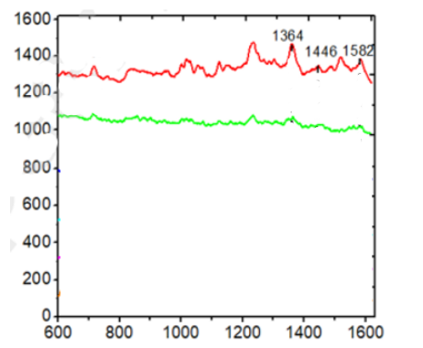

**Figure 46: https://dx.doi.org/10.2139/ssrn.4347307**

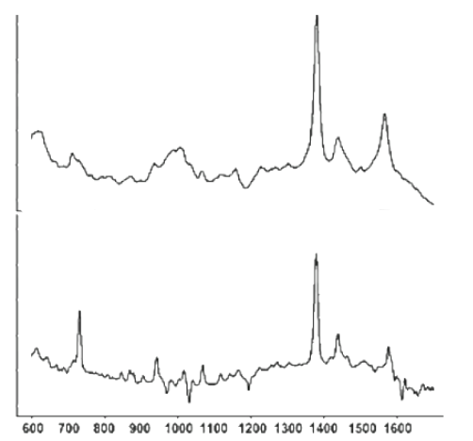

**Figure 47: https://doi.org/10.1007/s11947-011-0774-5**

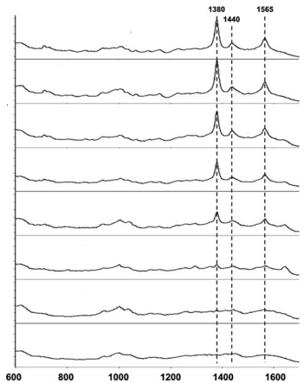

**Figure 48: https://doi.org/10.1007/s11947-011-0774-5**

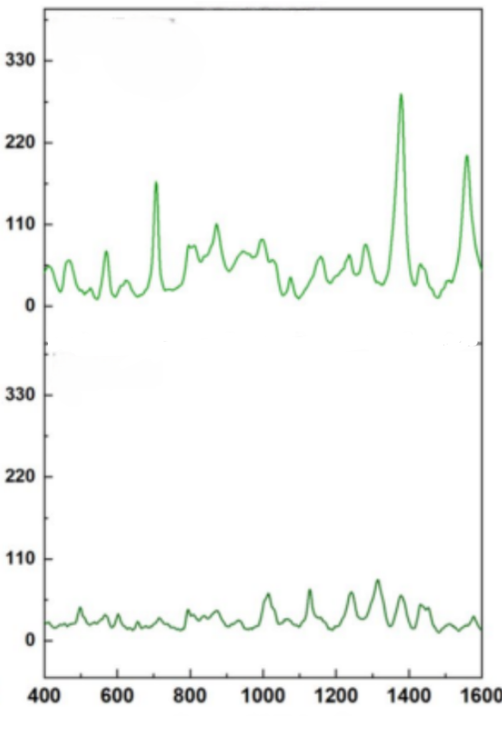

**Figure 49: https://doi.org/10.1007/s10570-024-06271-3**

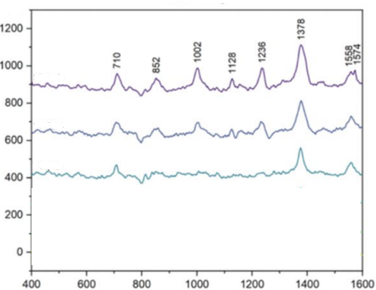

**Figure 50: https://doi.org/10.1007/s10570-024-06271-3**

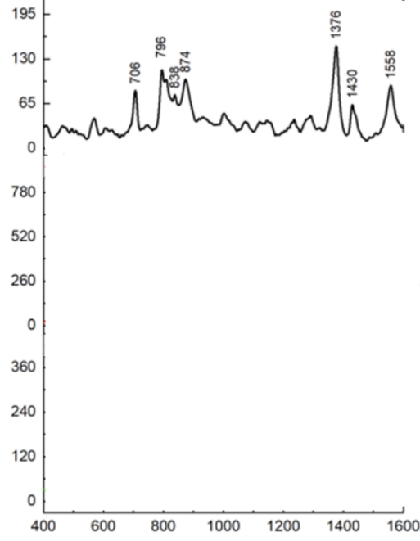

**Figure 51: https://doi.org/10.1007/s10570-024-06271-3**

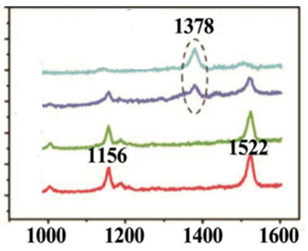

**Figure 52: https://doi.org/10.1016/j.vibspec.2016.09.005**

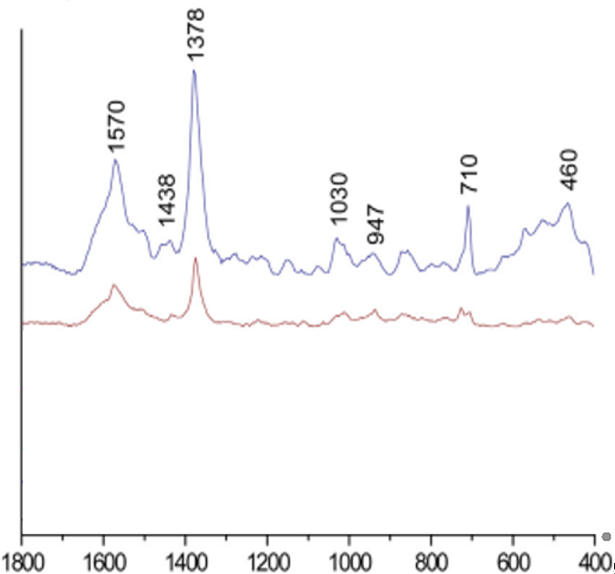

**Figure 53: https://doi.org/10.1016/j.vibspec.2016.09.005**

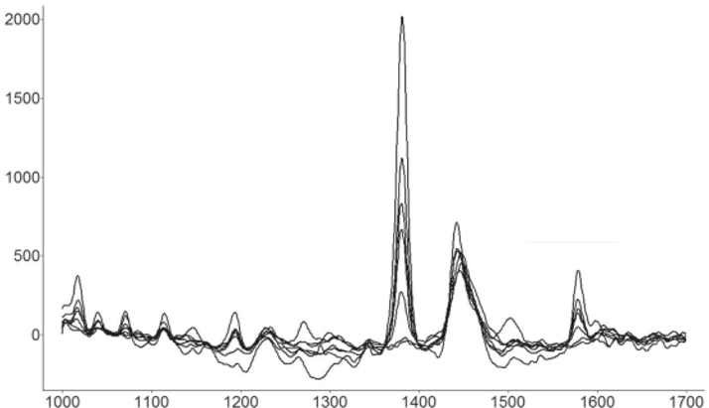

**Figure 54: https://doi.org/10.1111/1750-3841.12759**

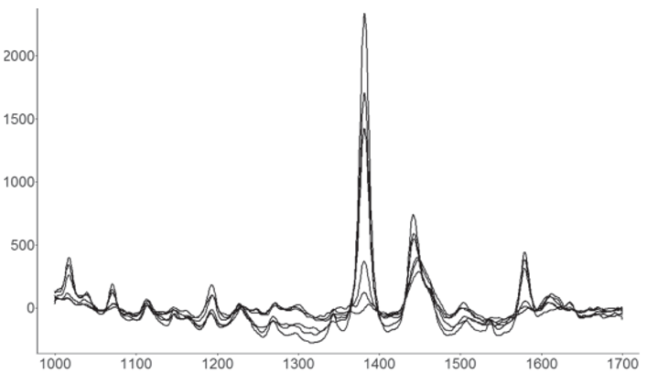

**Figure 55: https://doi.org/10.1111/1750-3841.12759**

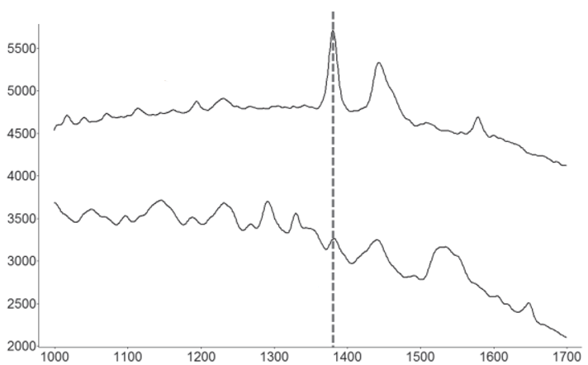

**Figure 56: https://doi.org/10.1111/1750-3841.12759**

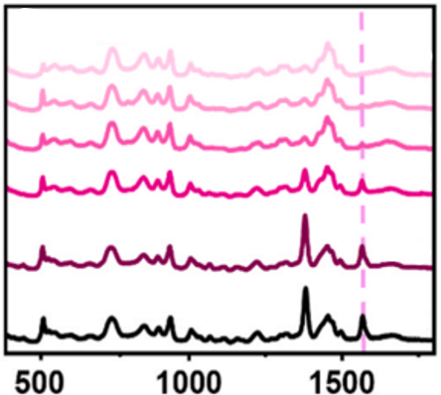

**Figure 57: https://doi.org/10.1016/j.jallcom.2024.177523**

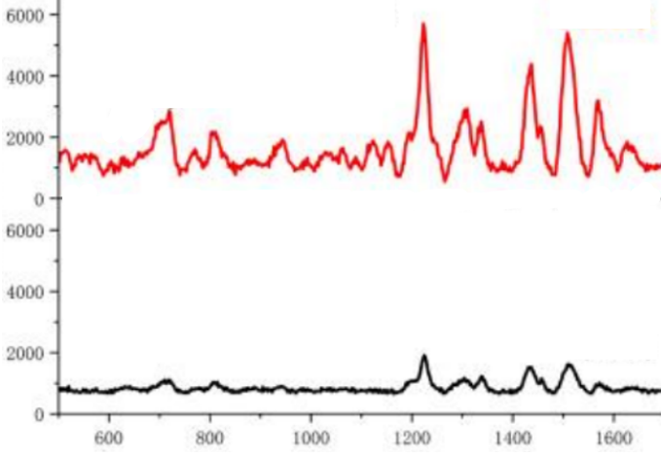

**Figure 58: https://doi.org/10.1002/cnma.201800389**

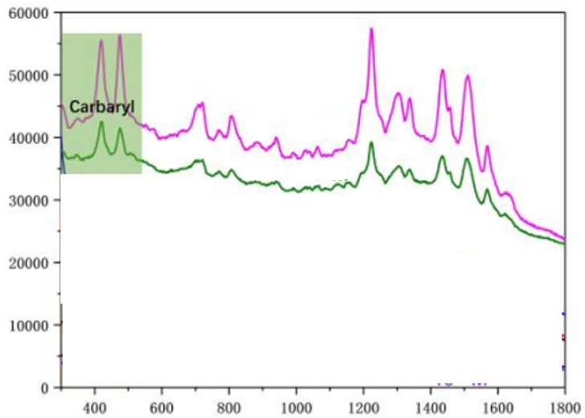

**Figure 59: https://doi.org/10.1002/cnma.201800389**

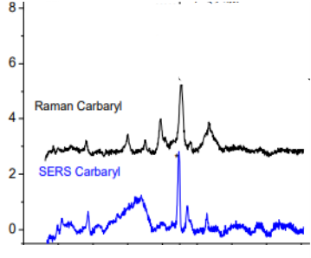

**Figure 60: https://doi.org/10.3390/molecules26020281**

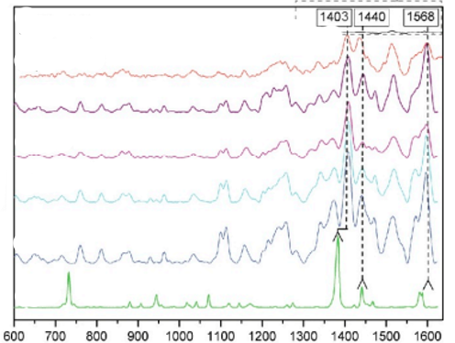

**Figure 61: https://doi.org/10.3390/bios9030111**

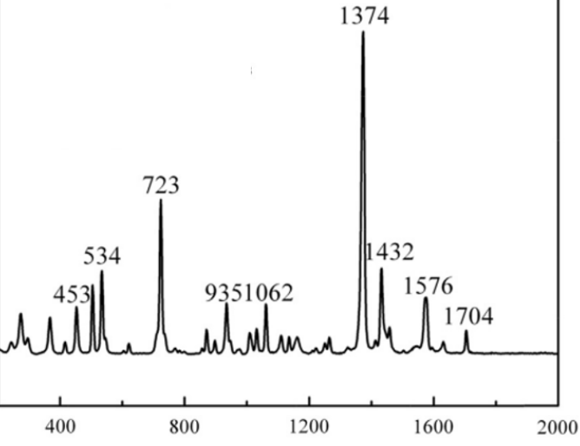

**Figure 62: https://doi.org/10.1016/j.lwt.2014.08.011**

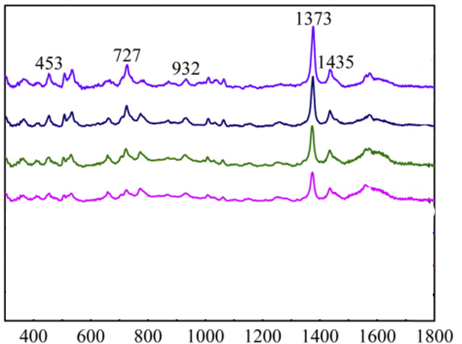

**Figure 63: https://doi.org/10.1016/j.lwt.2014.08.011**

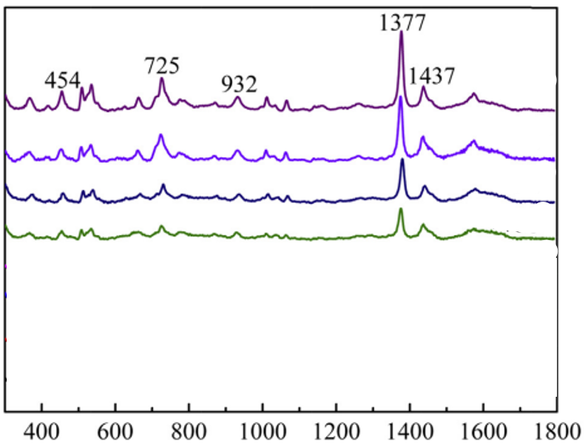

**Figure 64: https://doi.org/10.1016/j.lwt.2014.08.011**

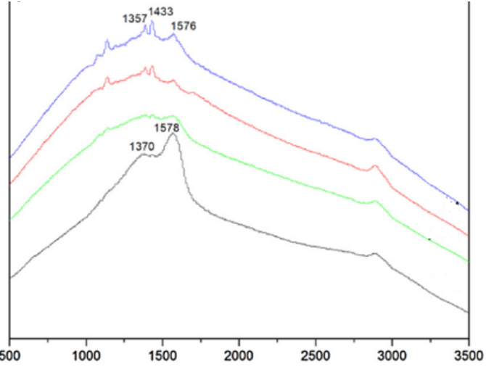

**Figure 65: https://doi.org/10.1016/j.snb.2018.05.075**

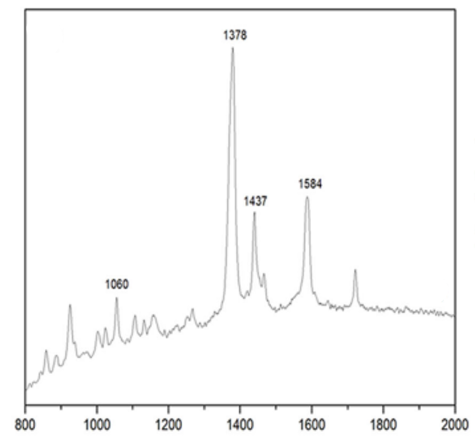

**Figure 66: https://doi.org/10.1007/s10570-019-02343-x**

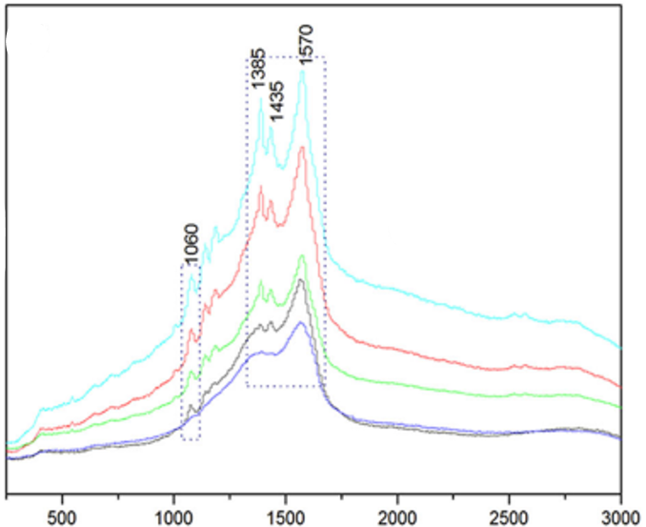

**Figure 67: https://doi.org/10.1007/s10570-019-02343-x**

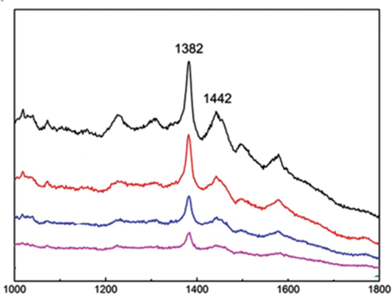

**Figure 68: https://doi.org/10.1166/jnn.2017.12544**

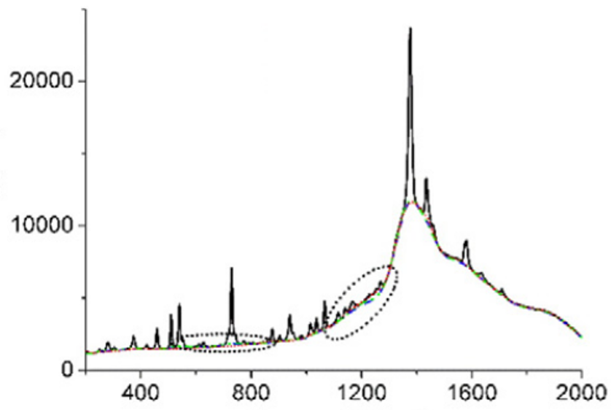

**Figure 69: https://doi.org/10.1016/j.chemolab.2016.01.005**

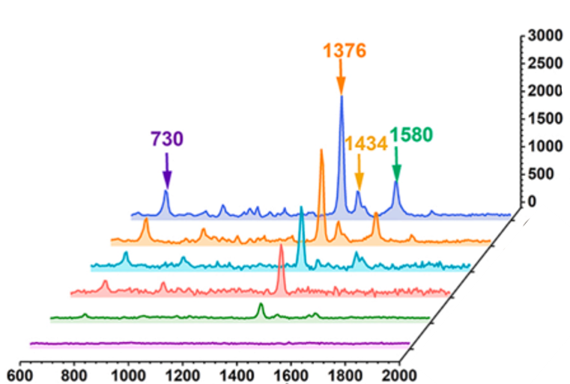

**Figure 70: https://doi.org/10.1016/j.colsurfa.2022.129014**

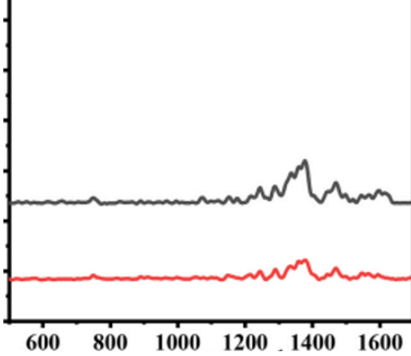

**Figure 71: https://doi.org/10.1016/j.snb.2025.138261**

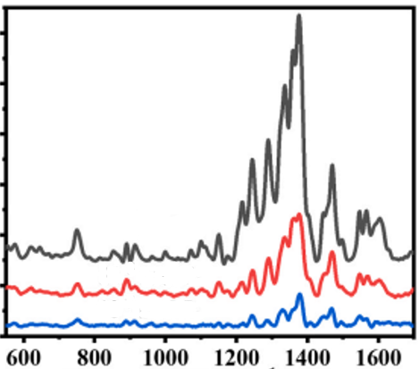

**Figure 72: https://doi.org/10.1016/j.snb.2025.138261**

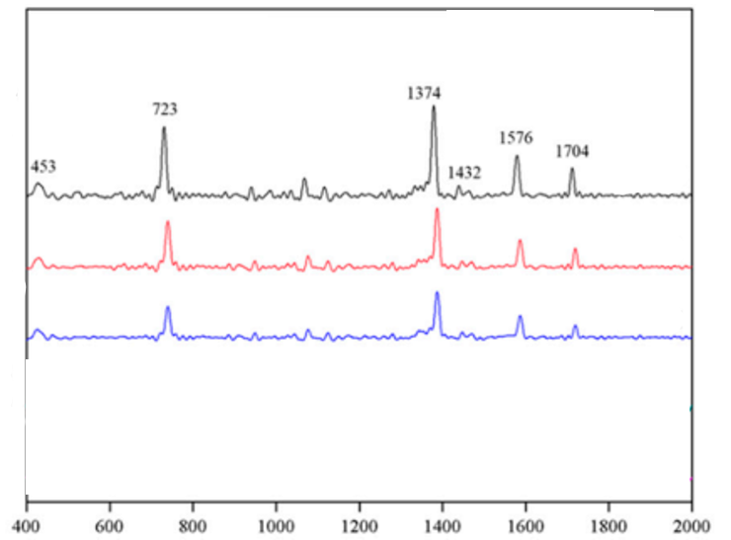

**Figure 73: <https://doi.org/10.3390/nano9050664>**

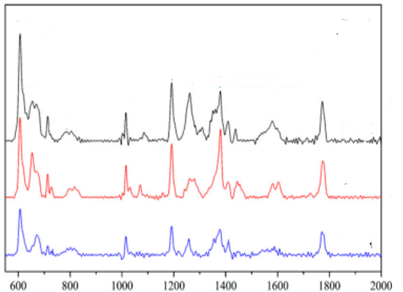

**Figure 74: <https://doi.org/10.3390/nano9050664>**

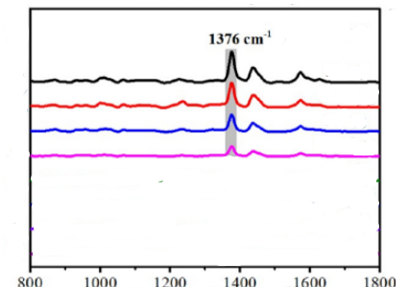

**Figure 75: https://doi.org/10.1021/acsami.0c17471**

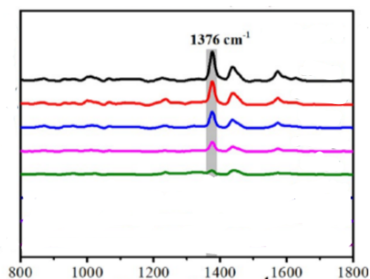

**Figure 76: https://doi.org/10.1021/acsami.0c17471**

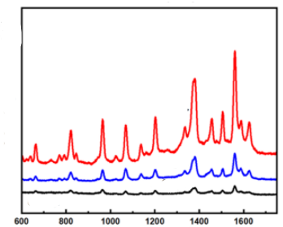

**Figure 77: https://doi.org/10.1021/acsanm.5c01351**

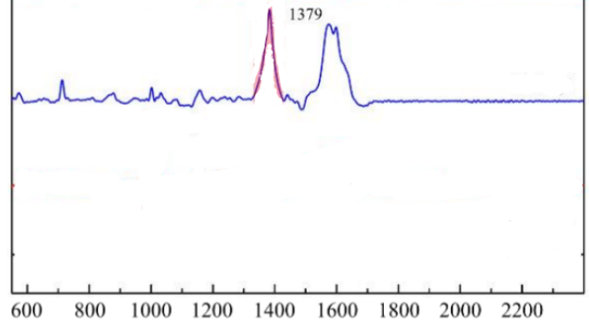

**Figure 78: https://doi.org/10.3390/nano8060402**

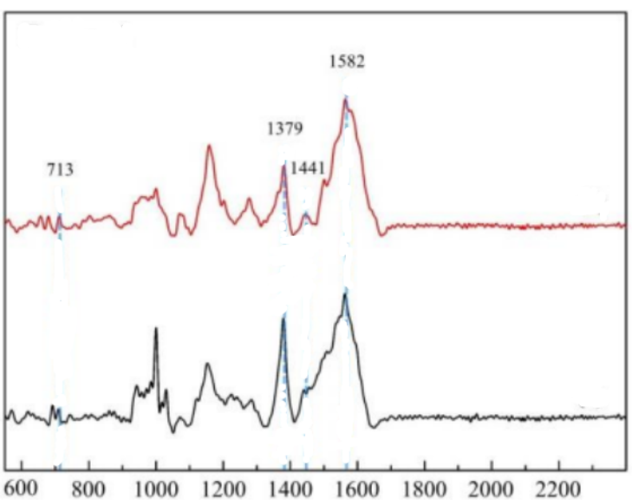

**Figure 79: https://doi.org/10.3390/nano8060402**

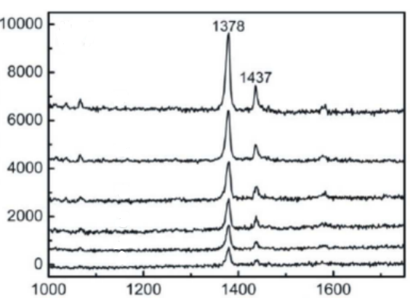

**Figure 80: https://doi.org/10.1039/C2JM33284A**

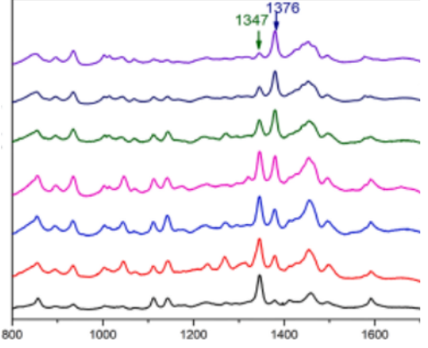

**Figure 81: https://doi.org/10.1016/j.foodchem.2022.133623**

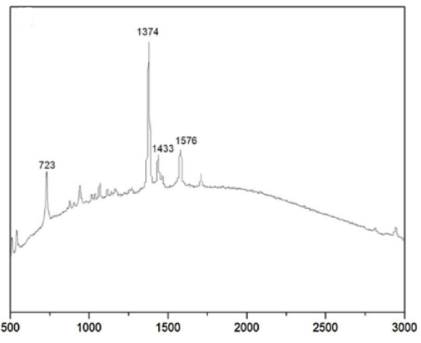

**figure 82: <https://doi.org/10.1016/j.snb.2018.05.075>**

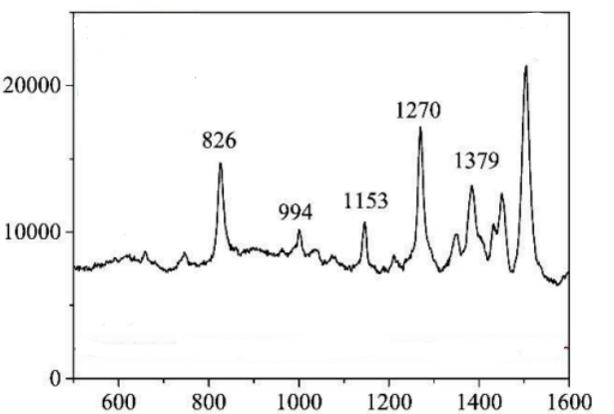

**figure 83: <https://doi.org/10.1016/j.apsusc.2017.11.288>**

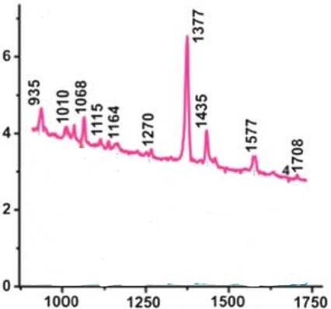



**figure 84: <https://doi.org/10.1039/C2AY25635E>**

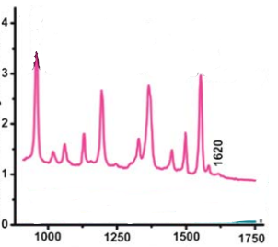



**figure 85: <https://doi.org/10.1039/C2AY25635E>**



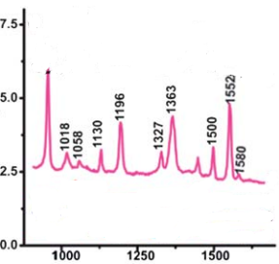

**figure 86: https://doi.org/10.1039/C2AY25635E**

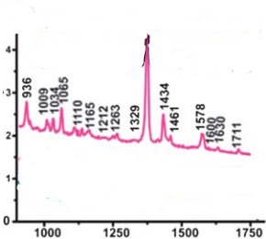



**figure 87: <https://doi.org/10.1039/C2AY25635E>**

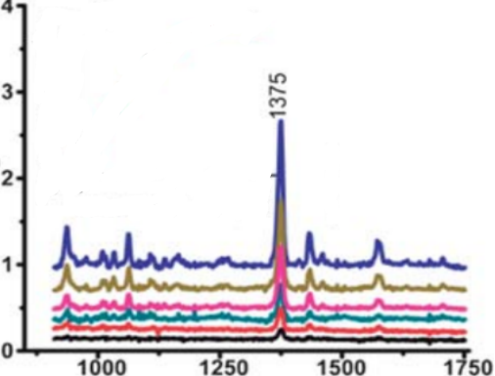

**Figure 88: <https://doi.org/10.1039/C2AY25635El>**

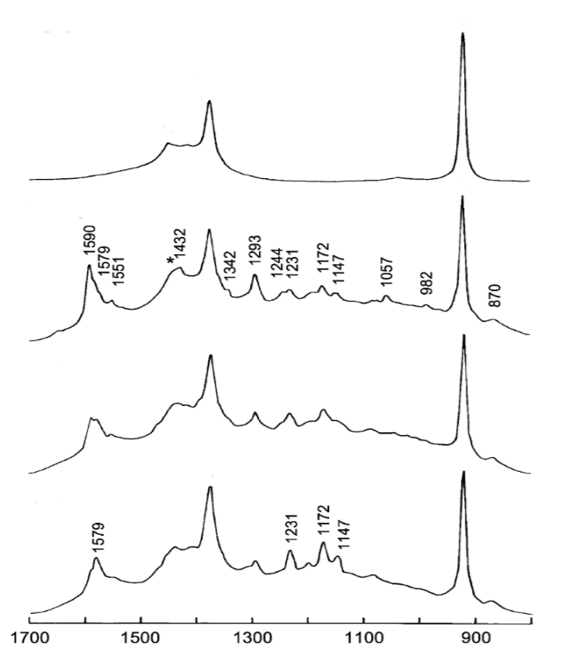

**Figure 89: <https://doi.org/10.1016/j.molstruc.2003.08.033>**

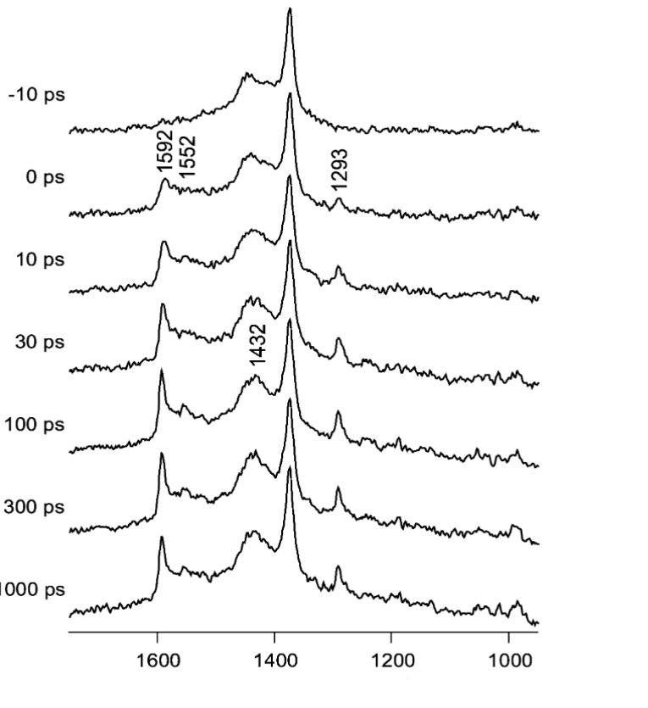

**Figure 90: <https://doi.org/10.1016/j.molstruc.2003.08.033>**

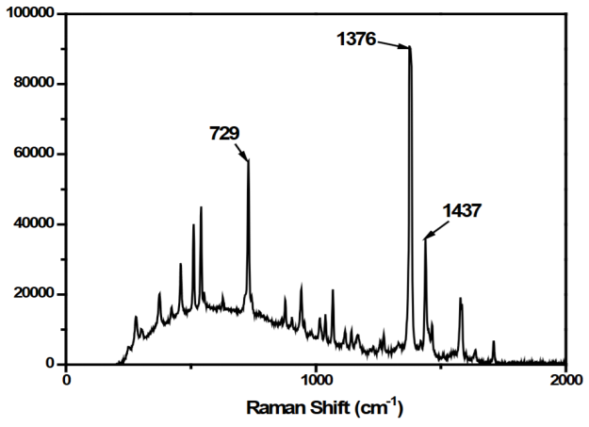

**Figure 91: <https://doi.org/10.4028/www.scientific.net/KEM.853.97>**

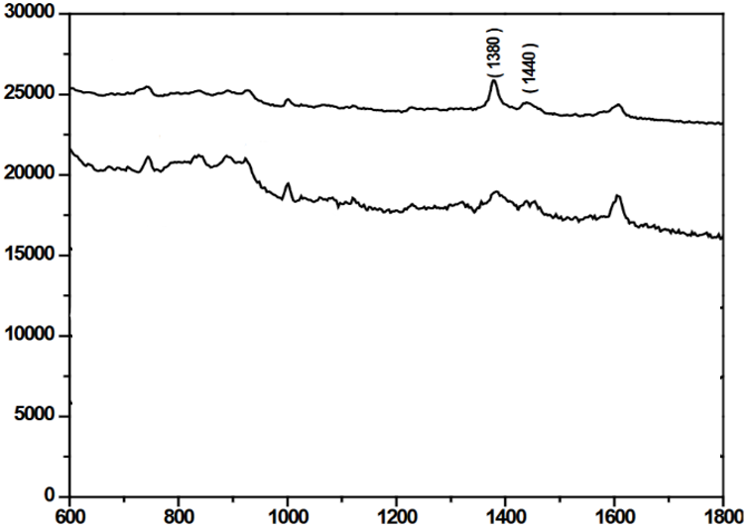

**Figure 92: <https://doi.org/10.4028/www.scientific.net/KEM.853.97>**

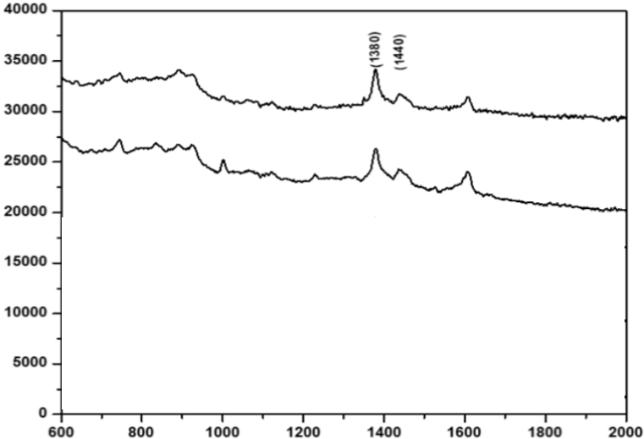

**Figure 93: <https://doi.org/10.4028/www.scientific.net/KEM.853.97>**

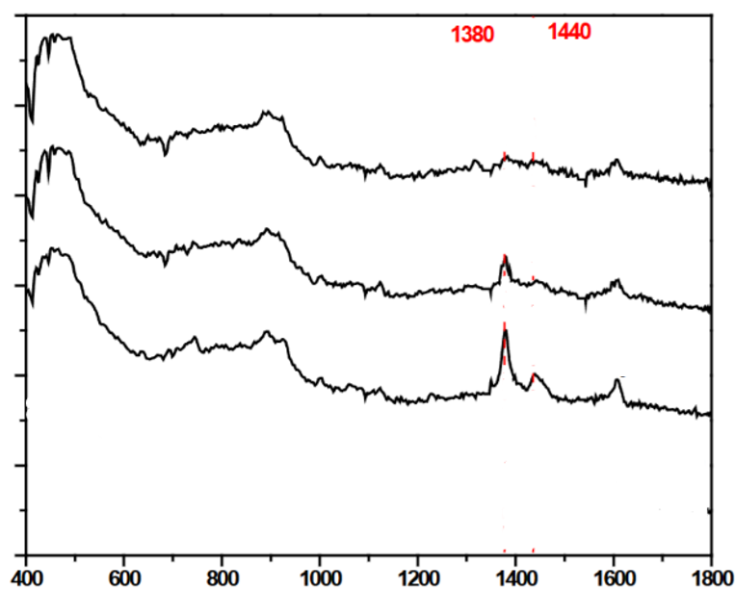

**Figure 94: <https://doi.org/10.4028/www.scientific.net/KEM.853.97>**

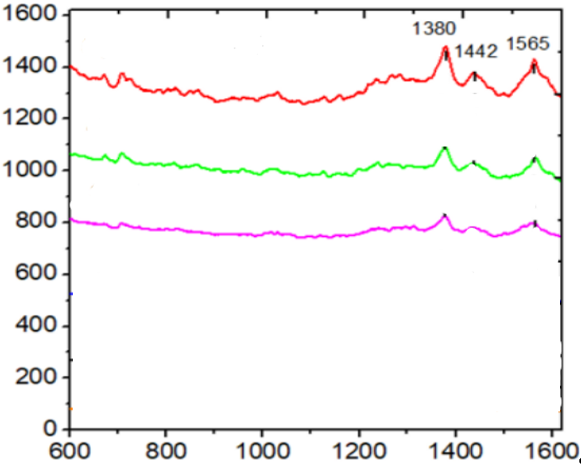

**Figure 95: [http://dx.doi.org/10.2139/ssrn.4270353](https://dx.doi.org/10.2139/ssrn.4270353)**

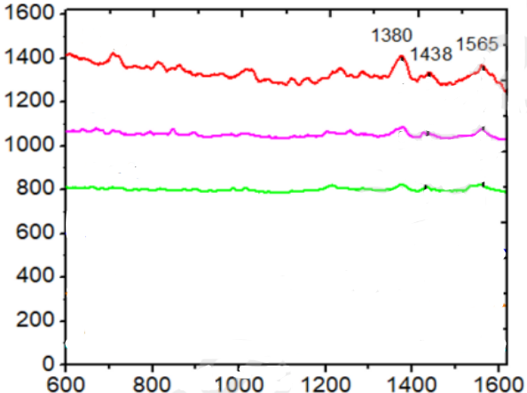

**Figure 96: [http://dx.doi.org/10.2139/ssrn.4270353](https://dx.doi.org/10.2139/ssrn.4270353)**

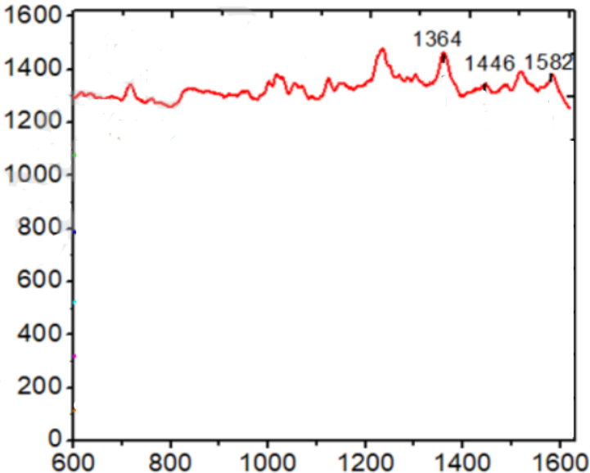

**Figure 97: [http://dx.doi.org/10.2139/ssrn.4270353](https://dx.doi.org/10.2139/ssrn.4270353)**

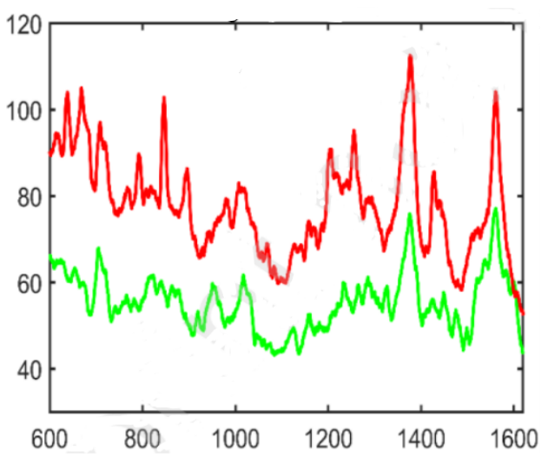

**Figure 98: [http://dx.doi.org/10.2139/ssrn.4270353](https://dx.doi.org/10.2139/ssrn.4270353)**

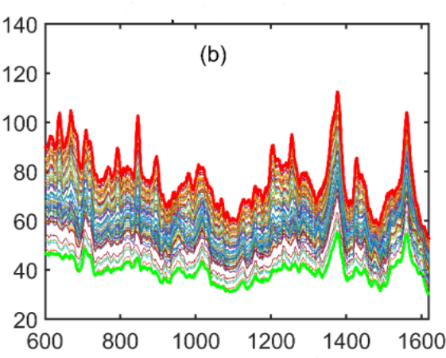

**Figure 99: [http://dx.doi.org/10.2139/ssrn.4270353](https://dx.doi.org/10.2139/ssrn.4270353)**

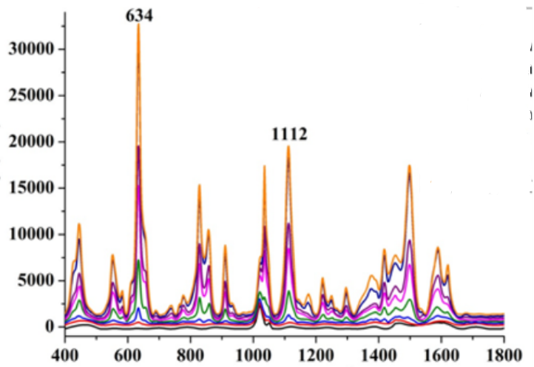

**Figure 100: <https://doi.org/10.1002/jsfa.10988>**

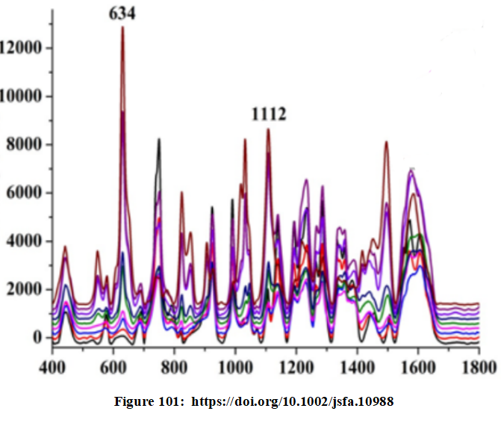

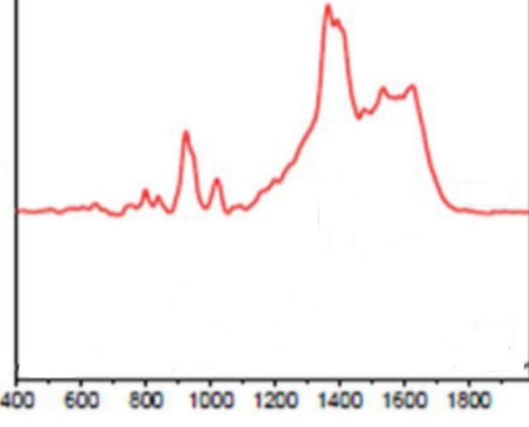

**Figure 102: <https://doi.org/10.1007/s11696-021-01594-y>**

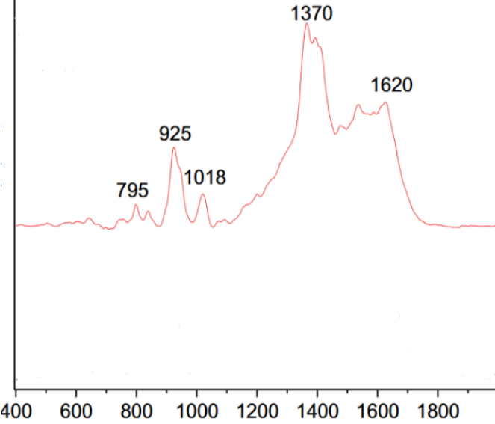

**Figure 103: <https://doi.org/10.1007/s11696-021-01594-y>**

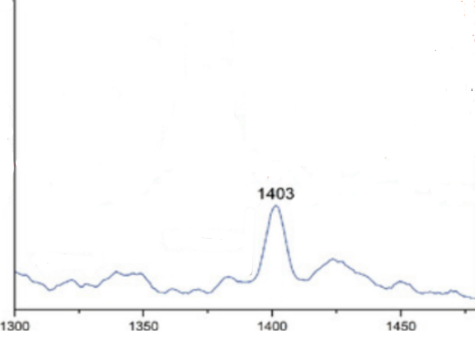

**Figure 104: <https://doi.org/10.3390/bios9030111>**

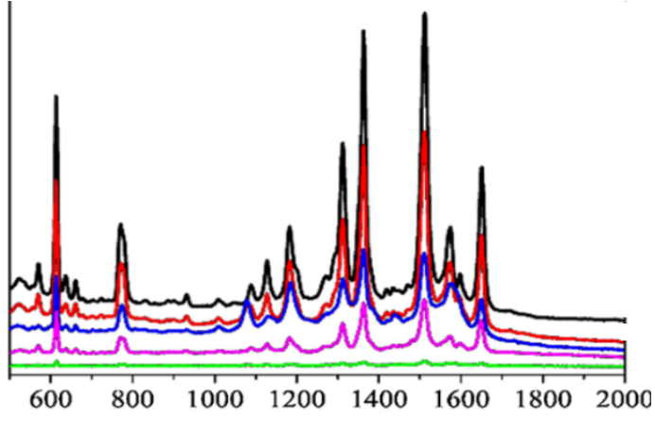

**Figure 105: <https://doi.org/10.1007/s10570-018-2209-1>**

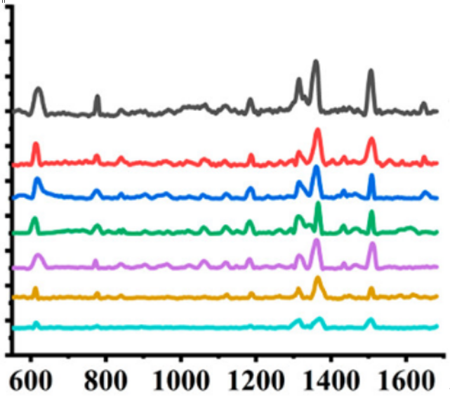

**Figure 106: <https://doi.org/10.1021/acs.langmuir.2c00187>**

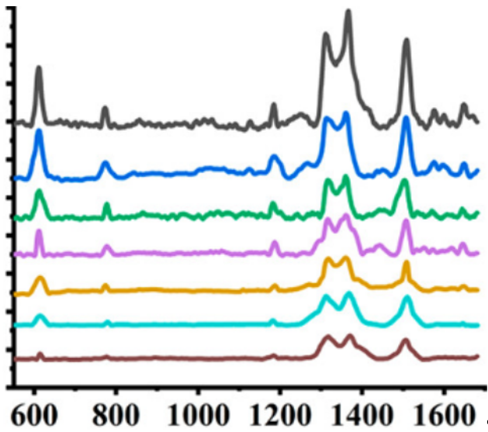

**Figure 107: <https://doi.org/10.1021/acs.langmuir.2c00187>**

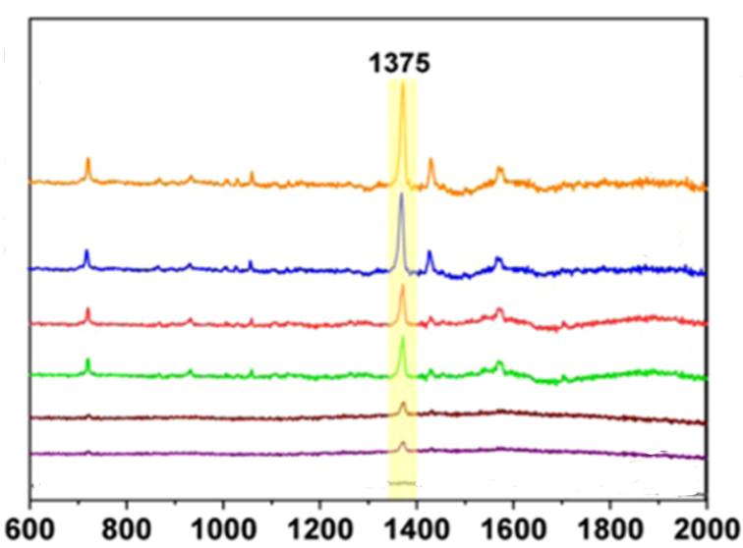

**Figure 108: https://doi.org/10.1021/acs.jafc.0c06562**

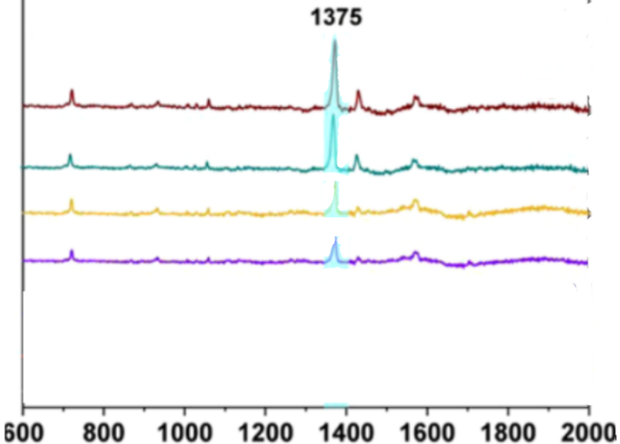

**Figure 109: https://doi.org/10.1021/acs.jafc.0c06562**

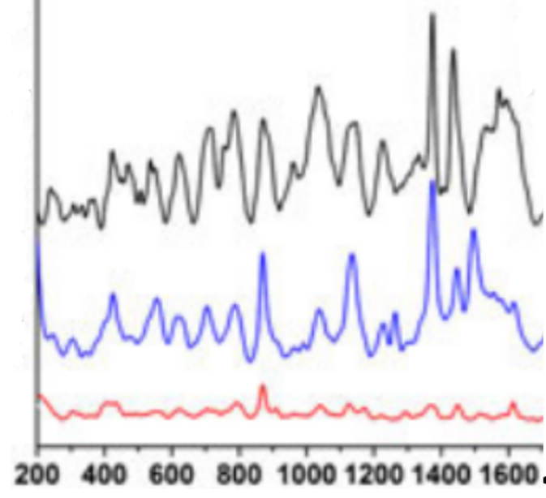

**Figure 110: https://doi.org/10.1002/jrs.4889**

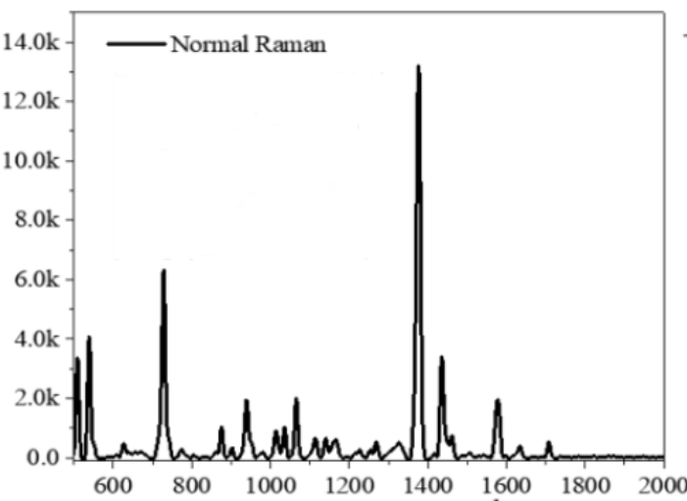

**Figure 111: https://doi.org/10.1021/acsphotonics.5c00721**

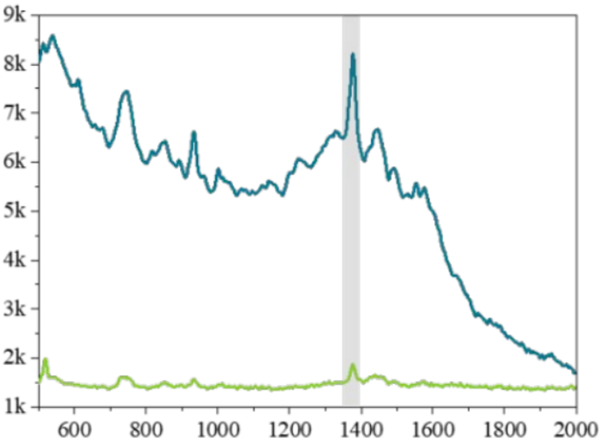

**Figure 112: https://doi.org/10.1021/acsphotonics.5c00721**

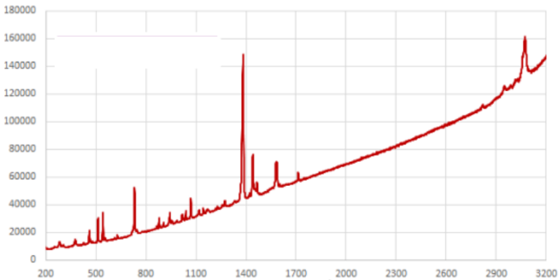

**Figure 113: https://doi.org/10.25949/19443887.v1**

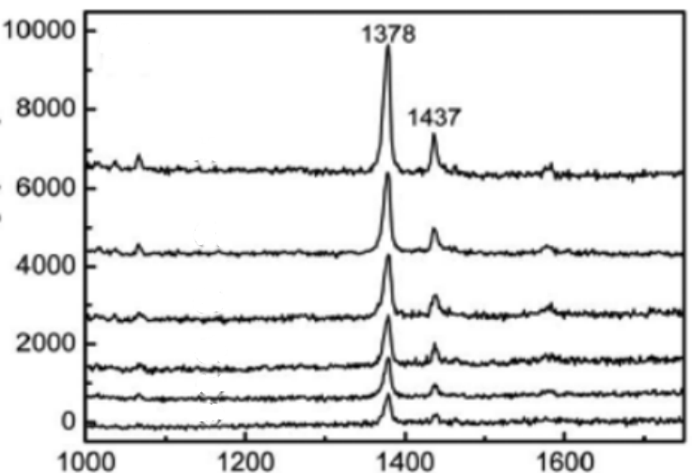

**Figure 114: https://doi.org/10.1007/s11814-013-0156-y**

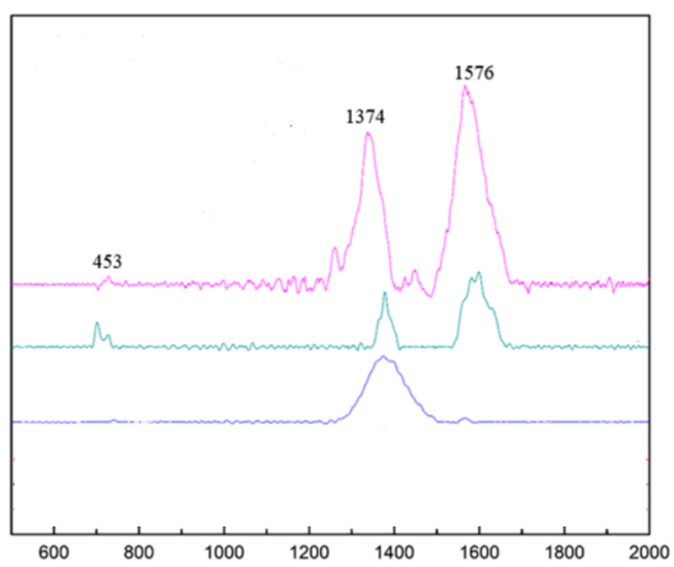

**Figure 115: https://doi.org/10.3390/nano9121750**

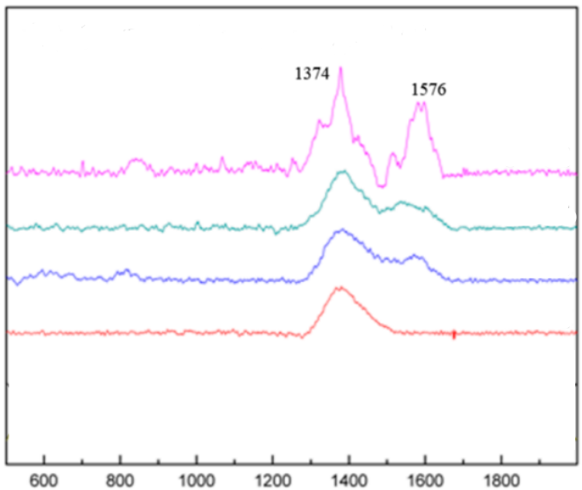

**Figure 116: https://doi.org/10.3390/nano9121750**

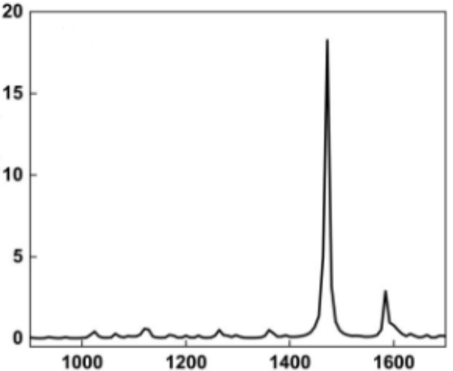

**Figure 117: <https://doi.org/10.1021/acsaom.5c00158>**

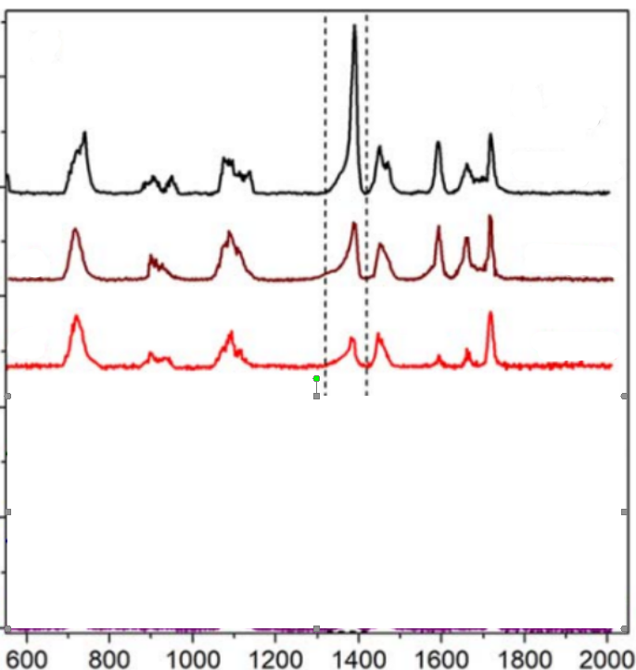

**Figure 118: https://doi.org/10.1088/2043-6254/ab6c5f**

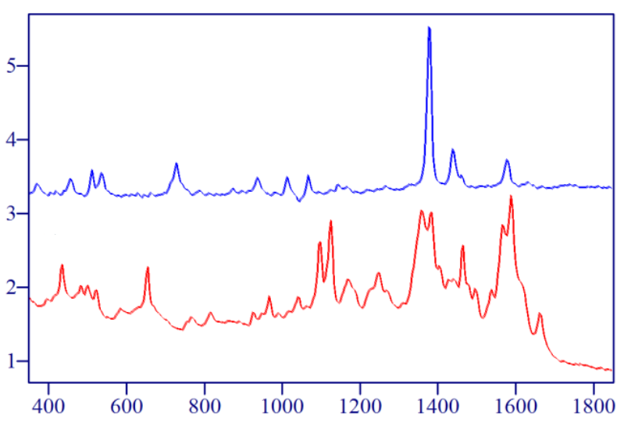

**Figure 119: https://doi.org/10.1117/12.569595**

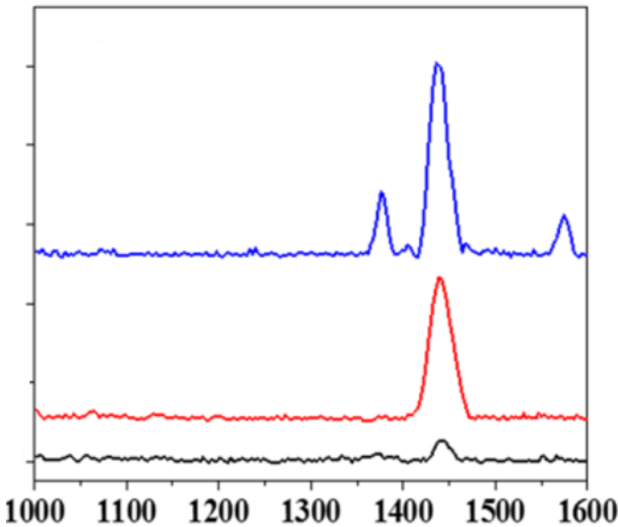

**Figure 120: https://doi.org/10.1007/s10570-019-02427-8**

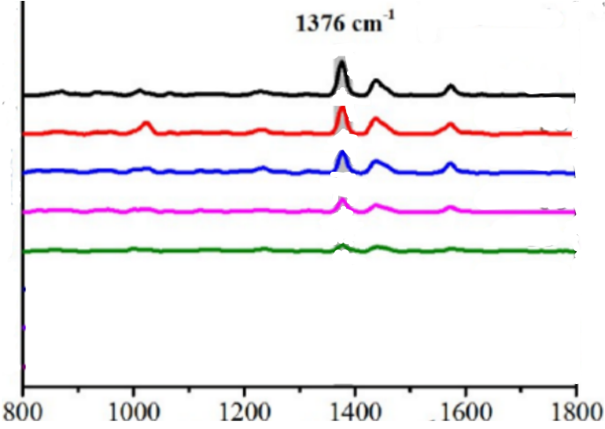

**Figure 121:** **https://doi.org/10.1021/acsami.0c17471**

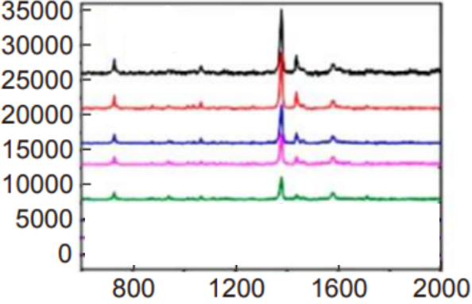

**Figure 122: https://doi.org/10.29026/oea.2021.210048**

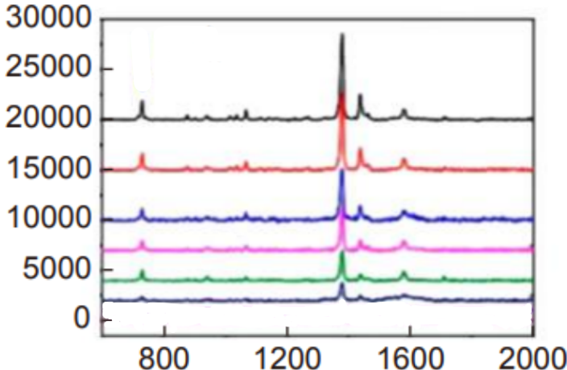

**Figure 123: https://doi.org/10.29026/oea.2021.210048**

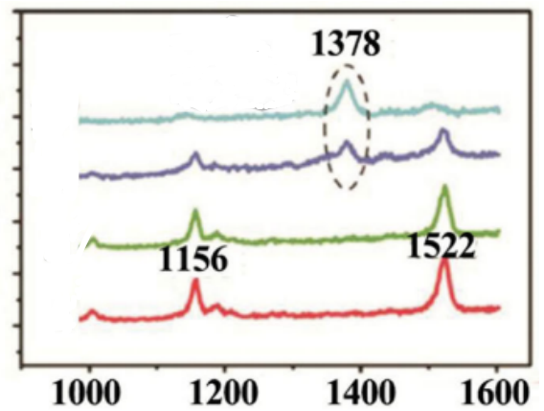

**Figure 124: https://doi.org/10.1002/smll.201401563**

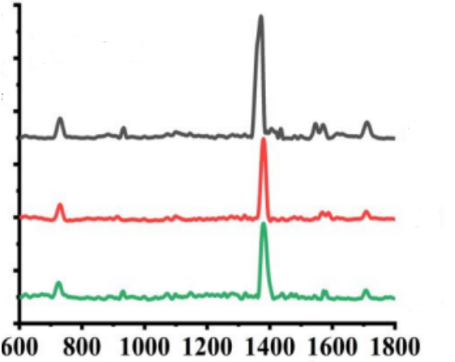

**Figure 125: https://doi.org/10.1021/acs.langmuir.2c00187**

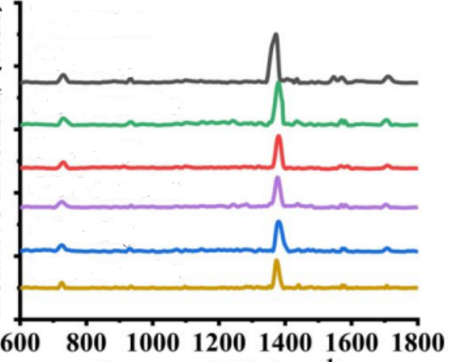

**Figure 126: https://doi.org/10.1021/acs.langmuir.2c00187**

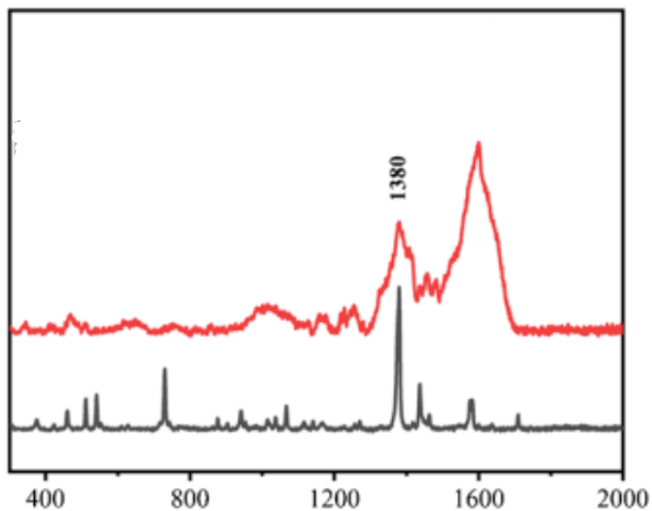

**Figure 127: https://doi.org/10.1007/s00216-025-05903-2**

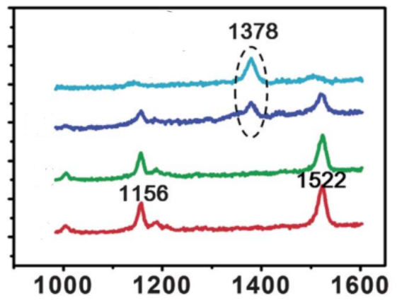

**Figure 128: https://doi.org/10.1039/C2JM31443F**

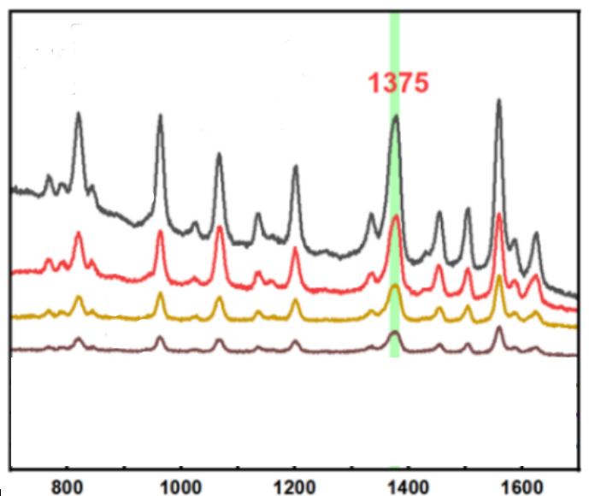

**Figure 129: https://dx.doi.org/10.2139/ssrn.5339459**